Assignment 8

●

**Prerequisite**

1. Routing Protocols.

2. Basics of Packet Tracer.

●

Learning Objectives:

1. To Understand Simulation Tool.

2. Should Able to Configure Routing Protocols

**1.3**Theory:

**1.3.1 Introduction**

ROUTING INFORMATION PROTOCOL:

The **Routing Information Protocol** (**RIP**) is one of the oldest distance-

vector routing protocols which employ the hop count as a routing metric.

RIP prevents routing loops by implementing a limit on the number of

hops allowed in a path from source to destination. The maximum number

of hops allowed for RIP is 15, which limits the size of networks that RIP

can support. A hop count of 16 is considered an infinite distance and the

route is considered unreachable. RIP implements the split horizon, route

poisoning and holddown mechanisms to prevent incorrect routing

information from being propagated.

Originally, each RIP router transmitted full updates every 30 seconds.

In the early deployments, routing tables were small enough that the

traffic was not significant. As networks grew in size, however, it became

evident there could be a massive traffic burst every 30 seconds, even if

the routers had been initialized at randomtimes. It was thought, as a result

of random initialization, the routing updates would spread out in time,

but this was not true in practice. Sally Floyd and Van Jacobsonshowed

in 1994 that, without slight randomization of the update timer, the timers

synchronized over time.

OPEN SHORTEST PATH FIRST: (OSPF)

●

●

OSPF is an interior gateway protocol (IGP) for routing Internet Protocol

(IP) packets solely within a single routing domain, such as an

autonomous system. It gathers link state information from available

routers and constructs a topology map of the network. The topology is

presented as a routing table to the Internet layer which routes packets

based solely on their destinationIP address.

Open Shortest Path First (OSPF) is a routing protocol for Internet

Protocol (IP) networks. It uses a link state routing (LSR) algorithm and

falls into the group of interior gateway protocols (IGPs), operating within

a single autonomous system(AS).

Aim: Problem Definition: Use packet Tracer tool for configuration of 3 router network

using one of the following protocol RIP/OSPF/BGP

**CONFIGURE ROUTING INFORMATION PROTOCOL (RIP)**

Open the router 1 (**R1**) which is the main router connected to ISP router. Do the

followingcommand for RIP Routing.

Enter configuration commands, one per line. End with

CNTL/Z.R1(config)#router rip

R1(config-router)#version 2

R1(config-router)#network 200.100.10.0

DHCP message types:

R1(config-router)#network 192.168.20.0

R1(config-

router)#networ

k 10.10.10.0

R1(config-

router)#

After enabling router with enable command then go to privileged mode with configure

terminal command. Now with router rip command, enable routing for all routers. The

version 2 Command, configure routing information protocol with version two. And next

set all network id like the above network command. I have set all three network which

connectdirectly to R1. Now go to router R2 and configure routing protocol the same as

router R1. On router 2 youmust assign the network ids of all connected network the R2

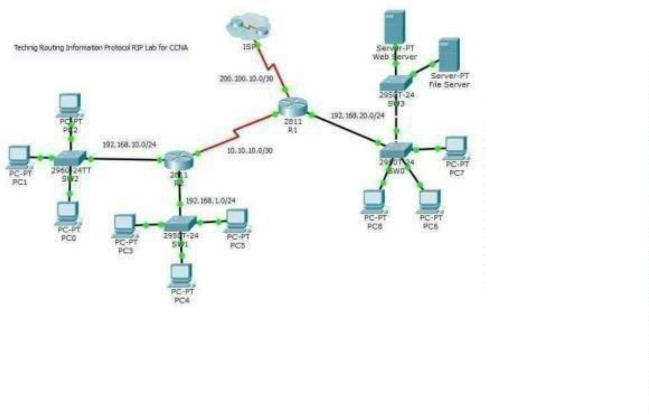

.

Enter configuration commands, one per line. End with

CNTL/Z.R2(config)#router rip

R2(config-router)#version 2

R2(config-router)#network 10.10.10.0

R2(config-router)#network 192.168.10.0

R2(config

-

router)#n

etwork

192.168.1

.0

R2(confi

g-

router)#

For ISP router, just enter the network id 200.100.10.0, because only one

networkconnected to ISP router.

ISP>

Enter configuration commands, one per line. End

with CNTL/Z.ISP(config)#router rip

ISP(config-router)#version 2

ISP(config-

router)#netw

ork

200.100.10.0

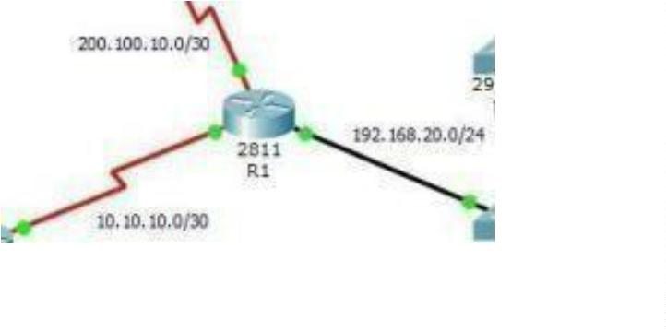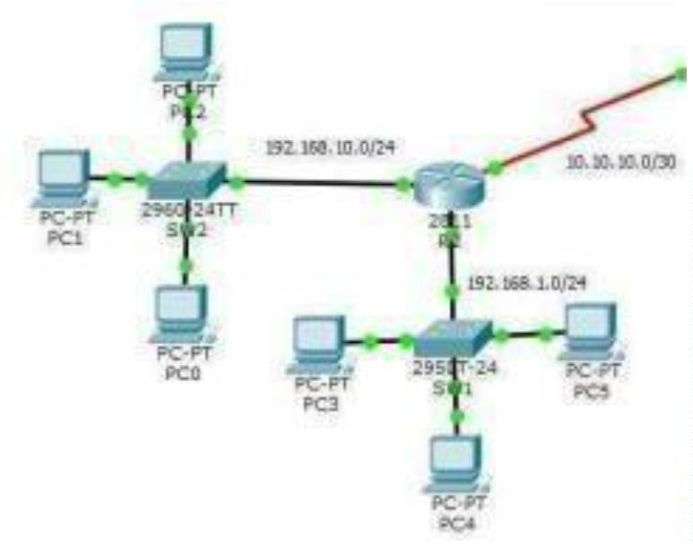

ISP(config-

router)#

CONFIGURE OSPF ROUTING PROTOCOL

In the router R1 configure OSFP routing with Router ospf command.

Enter configuration commands, one per line. End

with CNTL/Z.R1(config)#router ospf 1

R1(config-router)#network 20.10.10.0 0.0.0.3 area 0

R1(config-router)#network 10.10.10.0 0.0.0.3 area 0

R1(config-router)#network

1

0.10.10.4 0.0.0.3 area 0

R1(config-router)#

The router OSPF command is enable OSPF routing on the router, and the 1 before

OSFP is the process ID of the OSFP Protocol. You can set different process id

from “1-65535” for each router.

The network command with network ID “network 20.10.10.0” is the network

identifier, and the “ 0.0.0.3″ is the wildcard mask of 20.10.10.0 network.

Wildcard mask determine which interfaces to advertise, because OSPF advertise

interfaces, not networks

Now go to Router R3 and configure with the following commands.

R3>enable

R3#configure terminal

Enter configuration commands, one per line. End with CNTL/Z.

R3(config)#router ospf 1

R3(config-router)#network 192.168.1.0 0.0.0.255 area 0

R3(config-router)#network 10.10.10.0 0.0.0.3 area 0

Don? So do the following for router

R2.

R2>enable

R2#configure terminal

Enter configuration commands, one per line. End with CNTL/Z.

R2(config)#router ospf 1

R2(config-router)#network 192.168.10.0 0.0.0.255 area 0

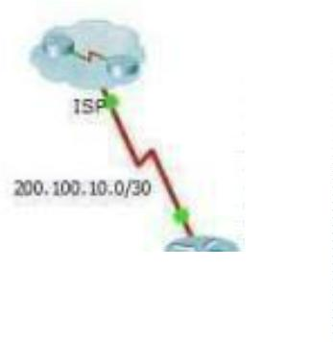

R2(config-router)#network 10.10.10.4 0.0.0.3 area 0

OK, OSPF routing configuration has been finished successfully, now test your network

whether they can ping with each other or not.

Conclusion:

Hence, we have studied Packet Tracer Properly

